**How to run Selenium’s Test Case(s) on Visual Studio 2015**

1. **System requirement**
   1. **Supported operating systems**

* Windows 10
* Windows 8.1
* Windows 8
* Windows 7 Service Pack 1
* Windows Server 2012 R2
* Windows Server 2012
* Windows Server 2008 R2 SP1
  1. **Hardware requirements**
* 1.6 GHz or faster processor
* 1 GB of RAM (1.5 GB if running on a virtual machine)
* 10 GB of available hard disk space
* 5400 RPM hard disk drive
* DirectX 9-capable video card that runs at 1024 x 768 or higher display resolution
  1. **Installation requirements**
* Install Visual Studio 2015
* Install Firefox 46
* GhostDoc 5.0

1. **Clone the repository from github.com**
   1. Open Visual Studio 2015
   2. Show Team Explorer (View>>Team Explorer)

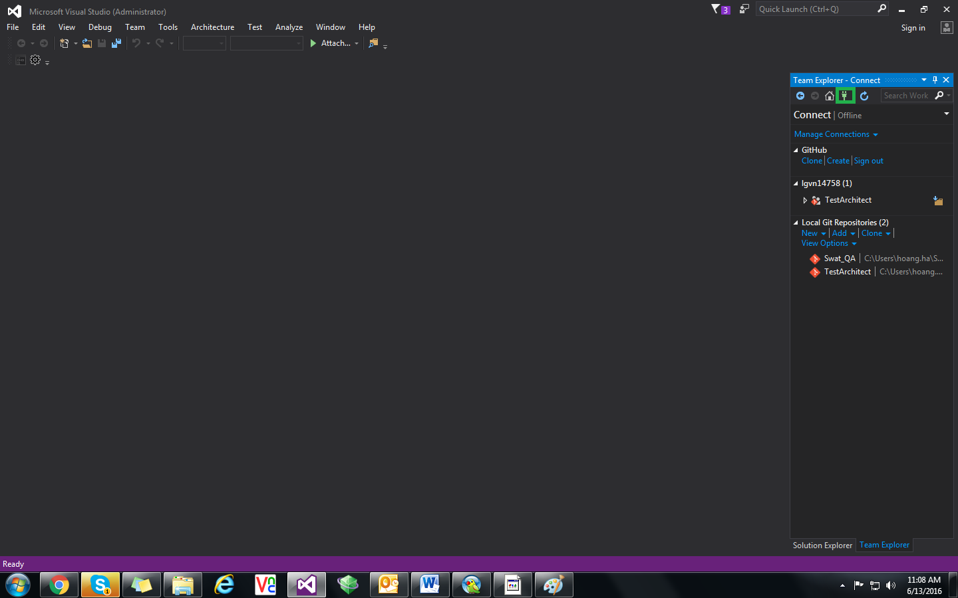

* 1. Change settings

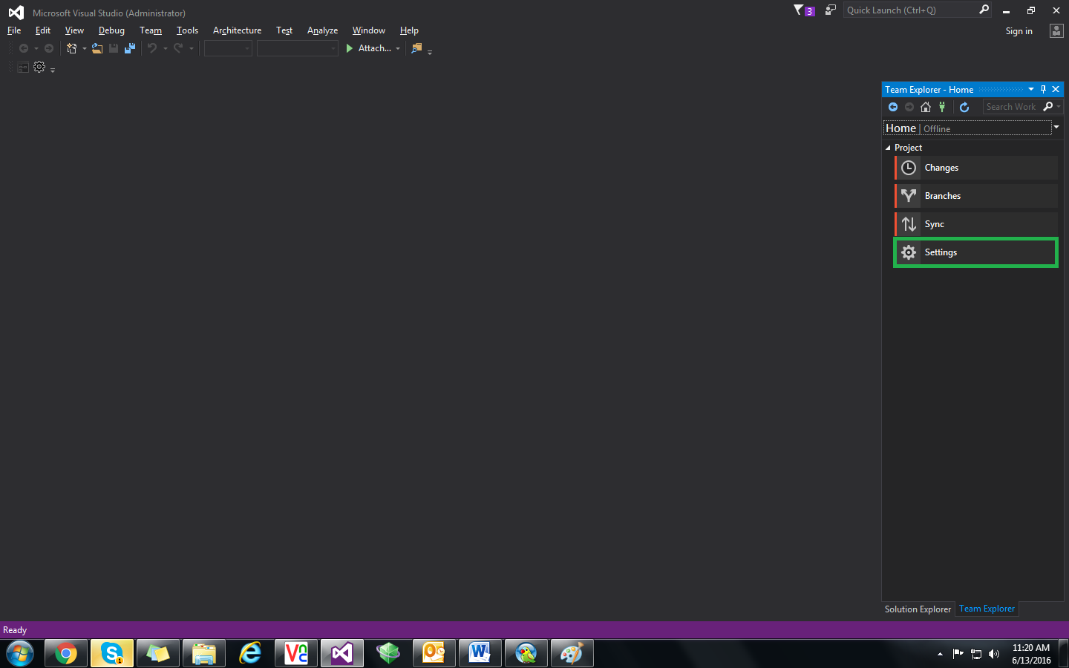

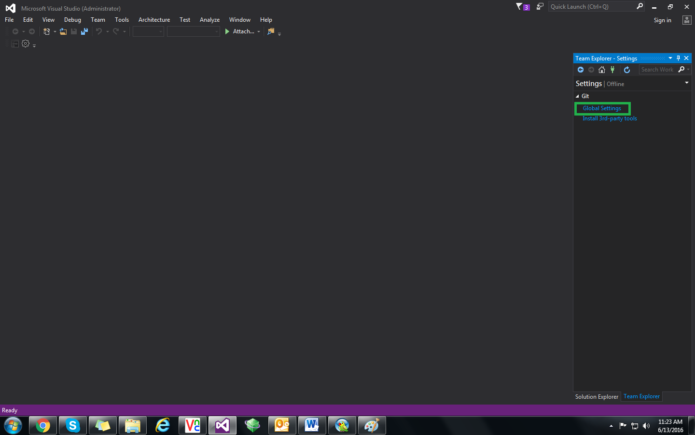

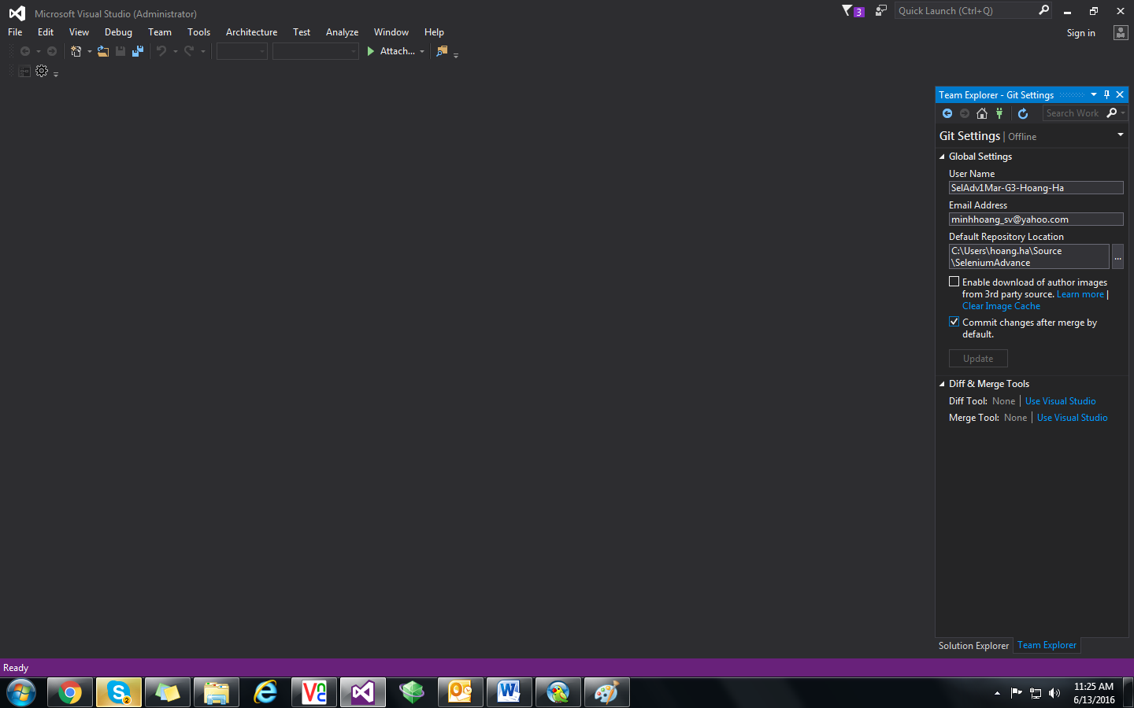

* 1. Clone repository

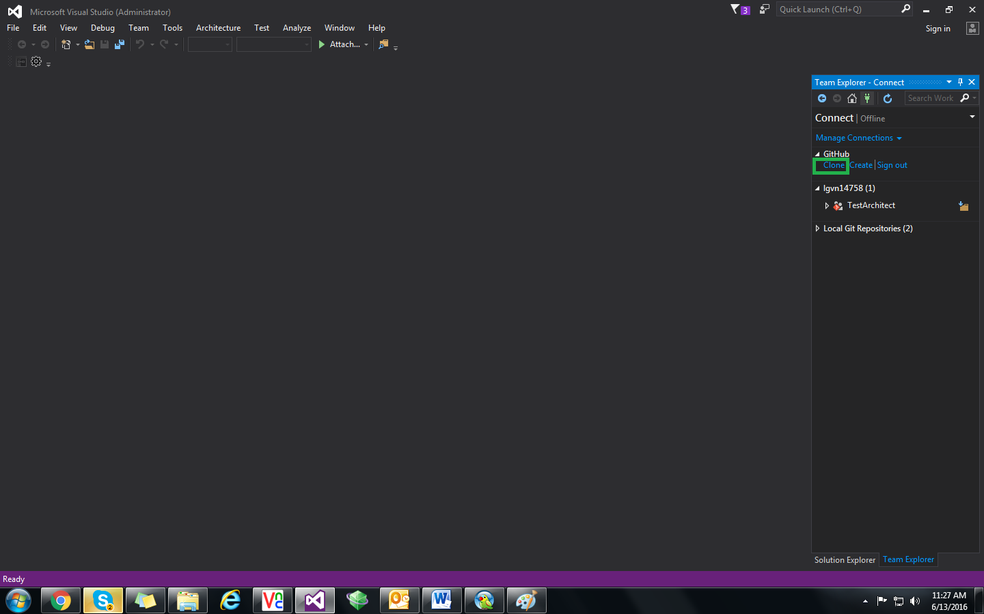

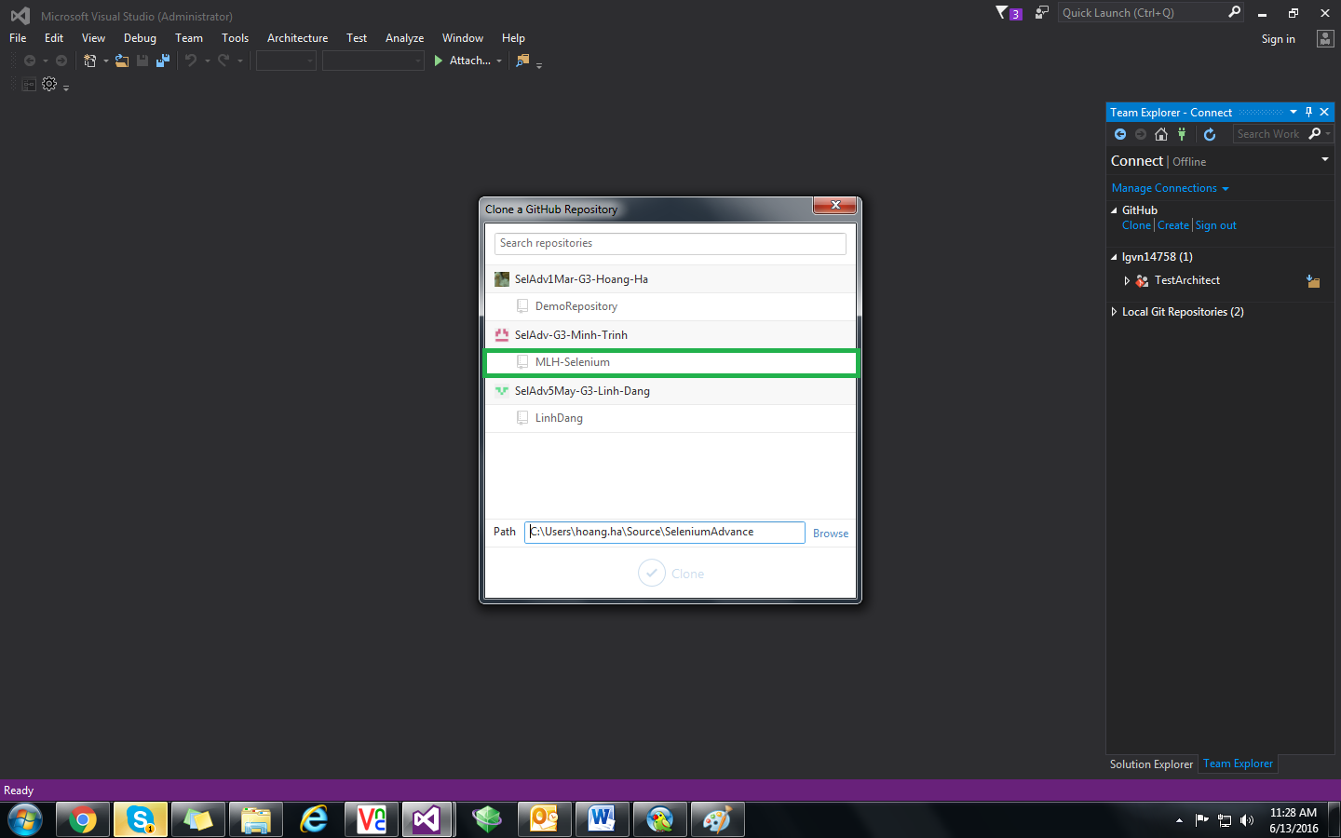

* 1. Verify the repository is cloned successfully

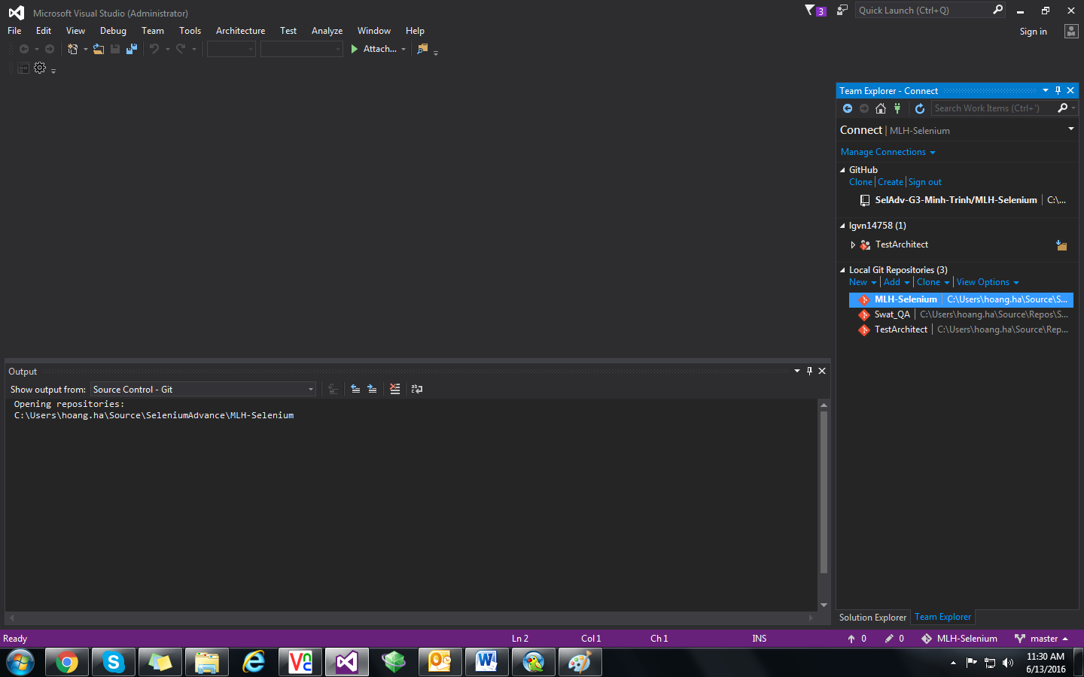

* 1. Open the solution

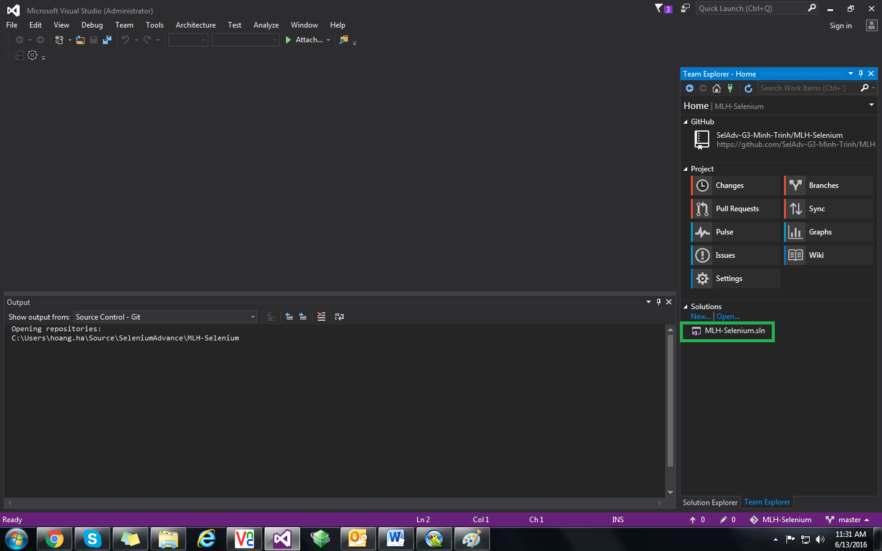

* 1. Show solution (View >> Solution Explorer)
  2. Verify the solution is opened successfully

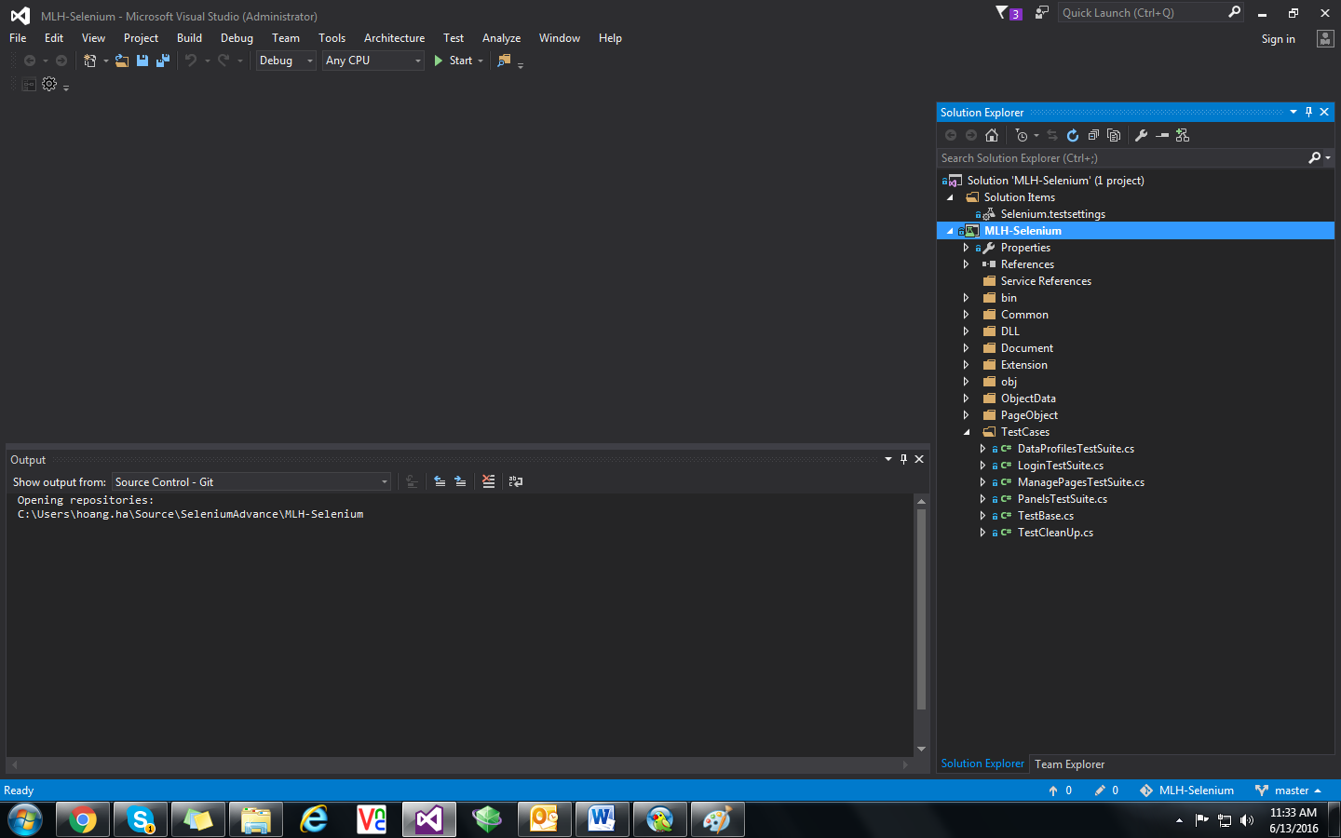

1. **Execute the Test Case(s) on Visual Studio 2015**
   1. Show Test Explorer (Test >> Windows >> Test Explorer)

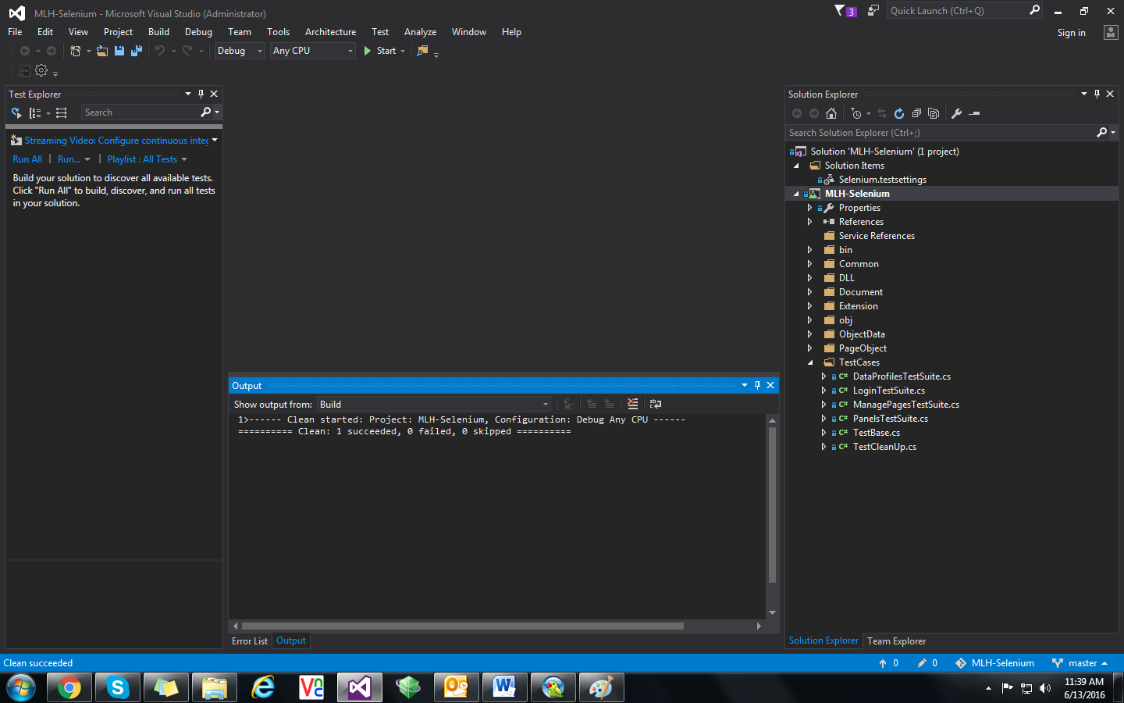

* 1. Clean Solution (Build >> Clean Solution)
  2. Build Solution (Build >> Build Solution)

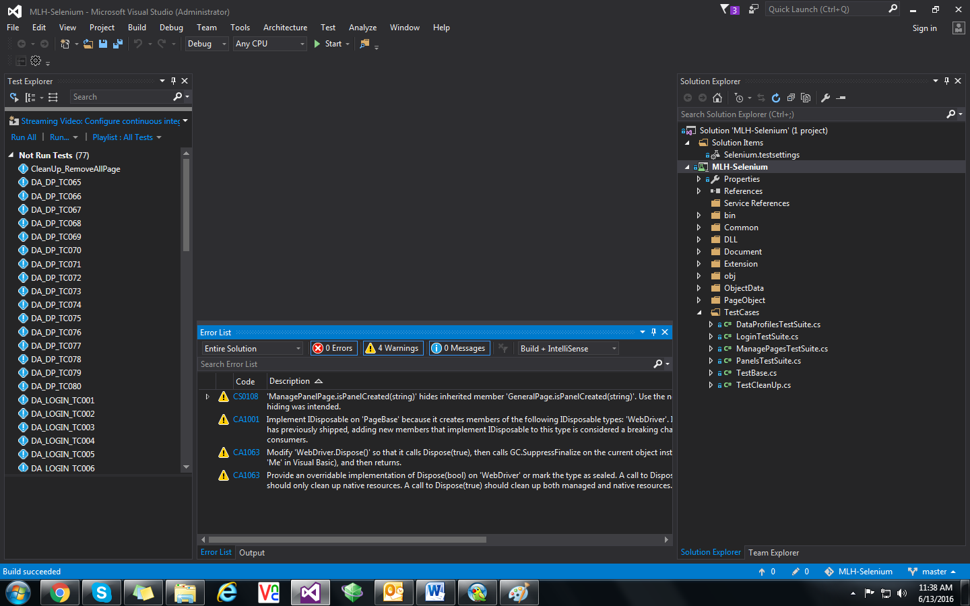

* 1. Execute a Test Case (Right click on the test case want to run and select “Run Selected Tests”)

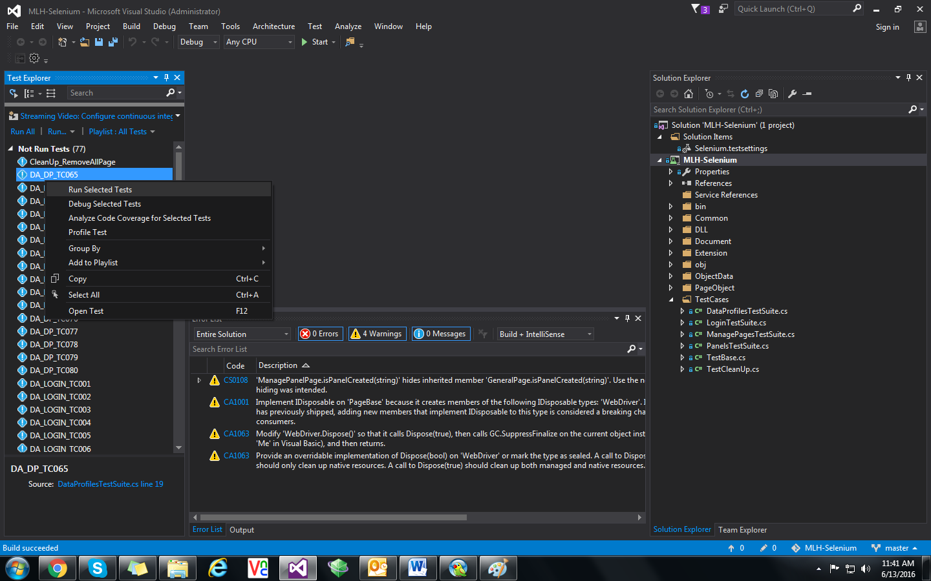

* 1. Execute multiple Test Cases (Select many Test Case/click on “Run all” link)

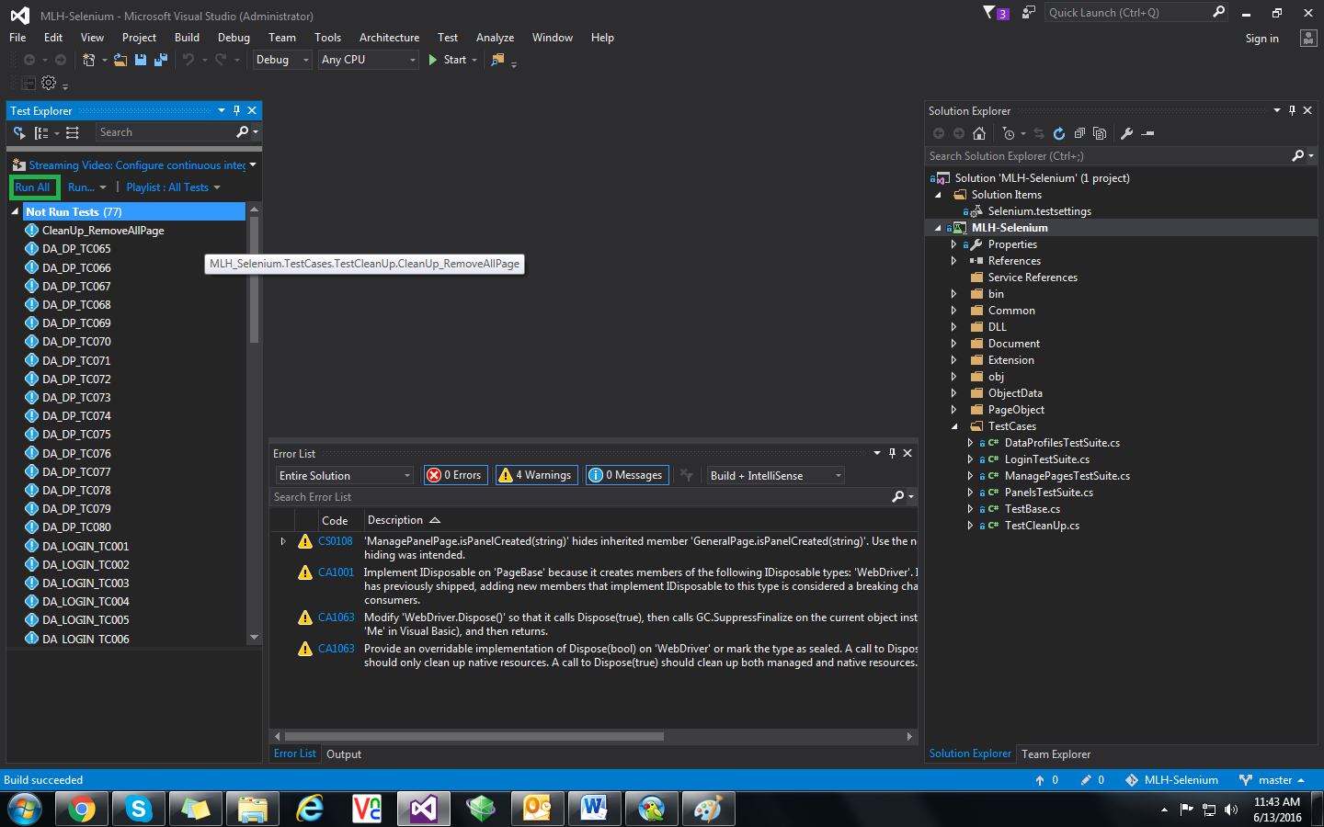

* 1. Verify the Test Case is running

